1. Scope of the Document 3
1.1. History and Evolution of Capacity Planning 3
2. The Capacity Planning Process 4
2.1. A Performance-driven Process at Network Level 4
3. Network Performance Indicators (as used in one ICAO Region 5
3.1. Average ATFM Delay per flight 5
3.2. Effective Capacity 5
4. Capacity Planning Process Workflow 6
5. Methodology to Assess Future Capacity Requirements 8
5.1 Assessment of current capacity: the Capacity Baseline 9
5.1.1 Reverse CASA: for ACCs with a capacity shortfall (delay producing) 10
5.1.2 NEVAC & ACCESS: for all ACCs, including those not producing delay 11
5.2 Expected Demand on the Future Route Network 14
5.2.1 Forecast Traffic Growth 14
5.2.2 Flight Increase Process (FIPS) and Airport capacity constraints 15
5.2.3 Future Route Network Evolution and Traffic Distribution 16
5.3 Cost Data and Economic Modelling 16
5.3.1 Capacity / Delay / Demand interaction and the Cost model 18
5.3.2 Optimum Cost Model ACC Capacity 19
5.4 Calculation of the Required Capacity Profiles 19
6 The Capacity Planning Work Programme 21
6.1 Actions, Deadlines and Responsibilities 21
6.1.1 Capacity Planning Meetings 24
6.1.2 ATFM and Capacity Report 25
6.1.3 Capacity Profile Scenario Development & Agreement 25
6.1.4 STATFOR Medium-Term Traffic Forecast 25
6.1.5 Medium-Term Capacity Profile Calculation 25
6.1.6 Delay Forecast 25
6.1.7 Capacity Planning Task Force 26
6.1.8 Network Operations Plan (NOP), Summer 26
6.1.9 European Medium-Term ATM Network Capacity Plan 26
6.1.10 Capacity Baseline Assessment 26
7 Capacity Planning – the broader view 28
7.1 Enroute 28
7.1.1 Future Developments 28
7.2 Airports 29
7.2.1 Airside Capacity Planning 29
7.2.2 Delay Reduction Initiative 29
7.2.3 Capacity/Demand Ratio Planning 31
7.2.4 Airport Collaborative Decision Making (A-CDM) 31
ANNEX A. List of Acronyms 32
ANNEX B. Commonly Understood Definitions 34
ANNEX C. The Capacity Planning Calendar 35
ANNEX D. EUROCONTROL Support for Local Capacity Planning 36
1 Support Services 36
2 Support Tools 37
ANNEX E. Airspace groupings for capacity assessment 41
ANNEX F. The Capacity Plan 43

Scope of the Document
This document describes the Air Traffic Management (ATM) network capacity planning process as it has been developed in European region. The process supports national ATC capacity planning, for enroute, terminal airspace and for airports, and identifies the tools and methodologies used.

History and Evolution of Capacity Planning
The most pressing problem facing Air Traffic Management (ATM) in some ICAO regions in the past decade has been to provide sufficient capacity to meet air traffic demand, while improving safety and containing costs. For instance, capacity provision in Europe lagged behind demand, leading to capacity shortfalls and delays to flights. This accentuated the need to improve capacity planning at European ATM network level.
The European ATM network capacity planning is a fully co-operative effort, with all stakeholders working closely with the EUROCONTROL Agency to ensure the timely delivery of ATM capacity. This is done through a comprehensive, transparent and interactive process, using various tools and ensuring cost-effective benefits from measures planned at network and local level.
Between 1999 and 2006, the European Summer ATM capacity increased by 45% for a traffic increase of 20%. Summer enroute ATFM delay decreased from 5.5 minutes per flight in 1999 to 1.4 minutes per flight in 2006.
This achievement was due to the measures put in place individually by ANSPs and collectively at network level, under the coordination of the EUROCONTROL Agency. The coordinated approach to European-wide capacity planning led to a widespread focus on capacity enhancement across Europe, with active participation of all stakeholders within a performance-driven approach towards ATM planning.

The European Capacity Planning Process

A Performance-driven Process at Network Level
The EUROCONTROL Air Traffic Management Strategy for the Years 2000+ (ATM 2000+) required the development of a performance-driven planning process to ensure that performance requirements would be met and operational improvements implemented.
A Capacity Enhancement Function (CEF) was created in 2000, responsible for ensuring a cohesive planning methodology, taking into account the whole European ATM network.
Central to this function is the annual capacity planning process, a cyclical process that identifies and quantifies the capacity requirements for the short and medium-term. These are assessed on the basis of the high-level capacity objective, which is to:
“provide sufficient capacity to accommodate the demand in typical busy hour periods without imposing significant operational, economic or environmental penalties under normal circumstances.”
This European network capacity requirement is translated into capacity requirements for Area Control Centres (ACCs).

To support ANSPs in their local capacity planning, EUROCONTROL makes an annual assessment of the capacity delivered and of the capacity required in the medium term for the European Civil Aviation Conference area (ECAC) enroute ATM system, taking into account the agreed target delay, the traffic forecast, the expected traffic distribution over the route network and the cost of air navigation service provision.
Five-year enroute capacity requirement profiles for ACCs are published annually. The profiles are used by ANSPs as a basis for cooperative planning and provision of capacity into the medium-term.
A reference capacity requirement profile is established for each ACC. Alternative scenarios, based on high and low traffic growth on shortest routes and medium traffic growth distributed on the current route network, are provided to support ANSPs in a more interactive and flexible planning of ATM capacity and to better reflect local conditions. Indications are given, from a network perspective, to ANSPs as to which scenario would best match their local conditions.
Local implementation plans describe the agreed common actions to be taken by various stakeholders, in the context of European ATM (EATM) to apply the Operational Improvements to the European ATM system, as set out in the strategy.
The inter-dependencies at network level are extremely high in Europe and the capacity planning process helps to ensure that integrated plans are developed locally and at network level, enhancing and making the best use of the European ATM capacity, in a cost-effective manner.

European Network Performance Indicators
To effectively determine future capacity requirements, it is necessary to monitor current network capacity performance. The following indicators are used:

Average ATFM Delay per flight
The average Air Traffic Flow Management (ATFM) delay per flight is the ratio between the total ATFM delay and the number of flights in a defined area over a defined period of time.
The ATFM delay is described as the duration between the last take-off time requested by the aircraft operator and the take-off slot allocated by the CFMU following a regulation communicated by the FMP, in relation to an airport (airport delay) or sector (enroute delay) location.
The average ATFM delay per flight is measured and monitored at network level over the whole ECAC area, as well as for individual ACCs and airports.

Effective Capacity

“Effective capacity” is defined as the traffic volume that the ATM system could handle with one minute per flight average enroute ATFM delay. This capacity indicator is derived from a linear relationship between delay variation and traffic variation.

Capacity Planning Process Workflow

Figure 1: The Annual Capacity Planning Process
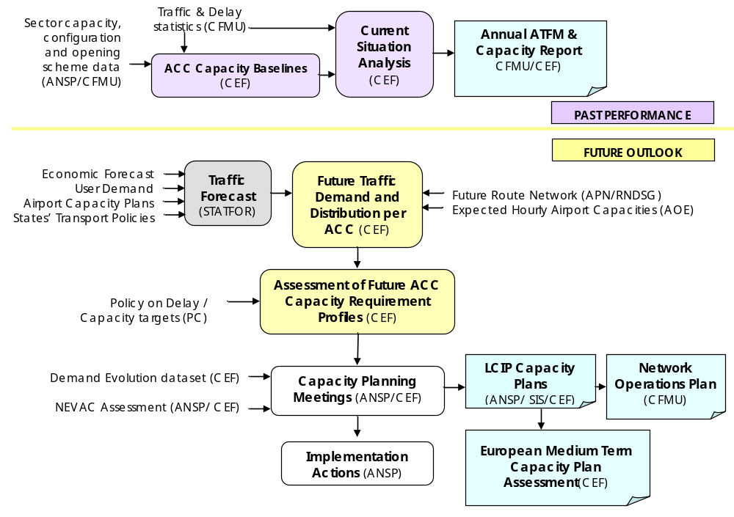

Methodology to Assess Future Capacity Requirements

The objective of a medium term planning exercise is to provide predictions of the ATM capacity requirement for the ATM system. To do this, the Future ATM Profile (FAP) was developed by EUROCONTROL.
FAP is a set of modelling and analysis tools comprising ATFM simulation facilities as well as spreadsheet and macro-based analysis and reporting tools, that assesses and quantifies how much capacity is delivered by specific airspace volumes within the current ATM system, and evaluates the current and future capacity requirements, at ACC and sector group level.
Step 1: In order to provide an accurate prediction of the capacity requirements of the European ATM system, it is necessary to know the current capacity offered. FAP establishes a capacity baseline for each ACC and defined sector group.
Step 2: The next task is to provide a prediction of the future demand on each ACC (and defined sector group) over the next 5 years, according to the expected traffic growth and distribution over the future route network.
Step 3: FAP carries out an economic analysis, balancing the cost of capacity provision and the cost of delay, on the assumption that each ACC is operating at or close to its economical optimum, and that the target level of delay has been achieved.
Step 4: FAP produces, for each ACC and defined sector group, a 5 year capacity requirement profile. Percentage increases with respect to the measured capacity baseline are provided.

Figure 2: Key FAP processes:
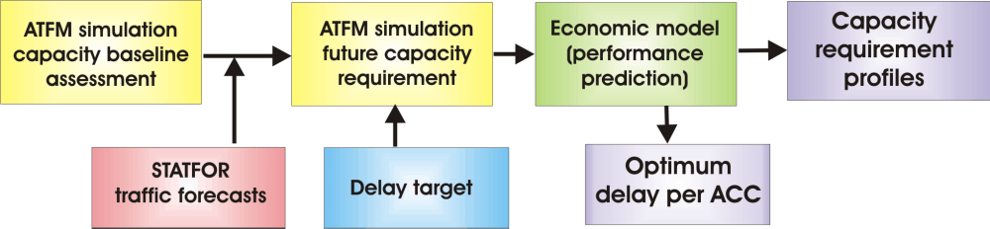

Assessment of current capacity: the Capacity Baseline
There are several methods to evaluate current ACC and sector group capacity, known as the capacity baseline. These have been developed and improved over a number of years and the suitability and effectiveness of each depends on whether or not the ACC being measured generates a significant amount of ATFM delay. The most accurate for delay producing ACCs is Reverse CASA, with NEVAC being the preferred option for non delay-producing ACCs until ACCESS was developed in 2004. The ACCESS methodology was developed to enable the baseline of all ACCs to be assessed using one methodology, and to ensure a continuity for ACCs that move from one category into the other.
The use of all three baseline assessment methodologies will continue for a transition period until the ACCESS process has been fully validated.
A comparison of the different methodologies is given in the table and fully described in the paragraphs below.

Method | Advantages | Disadvantages | Comment
Reverse CASA | - Extremely accurate measurement of ATM capacity offered during the measured period  - Takes network effect into account  - No input from ANSPs | - Useful only for delay-producing ACCs  - Iterative simulation takes time | - Analysis of ATFM delay  - Excludes delays caused by weather and/or special events
NEVAC | - Can be used for all ACCs  - Measures the potential capacity that could be offered during the period  - Quick and easy | - Does not take the network effect into account  - Results depend on the accuracy of CFMU data  - Cannot measure offered capacity, only potential | - Uses CFMU data on available sector configuration and declared capacities
ACCESS | - One method for all ACCs  - Continuity for ACCs that change categories  - Measures capacity offered during the period  - Takes network effect into account | - Requires proactive input from ANSPs to ensure accurate data  - Iterative simulation takes time | - ANSP must provide detailed information on actual sector opening schemes and sector capacities (or confirm accuracy of CFMU environment archive)

Reverse CASA: for ACCs with a capacity shortfall (delay producing)
The estimation of current ACC capacity is based on an analysis of the ATFM delays observed during the analysis period. The days chosen for study correspond to a set whose observed delay correlates well with the observed yearly delay distribution. A series of Summer days are chosen, because in most ACCs this corresponds to the period of peak demand and therefore represents the ideal benchmark for the definition of future performance criteria.
The capacity measurement is made by Reverse CASA on a daily basis over 2 AIRAC cycles during the Summer season, excluding delays for weather, special events etc.; the result may not fully correspond to the maximum capacity, as it can be influenced by restrictions associated with reduced configurations.
The initial objective within FAP is to determine the equivalent ACC ‘observed’ capacity i.e. the number of aircraft which could pass through the ACC whilst generating the same ATFM delay as was actually observed. In flow management terms it is as though the ACC is regulated by a single regulation over the whole ACC.
Unfortunately, the CASA algorithm cannot simply be employed using an inverse function i.e. given delay figures it cannot provide capacity values. Hence for each ACC it is necessary to consider the delay which would have been observed for a hypothetical estimate of capacity.
The calculated delay is then compared to that which was observed and an iterative modification cycle commences until the CASA determined delay within a particular ACC for an estimated value of capacity converges to that observed for the day in question. This methodology is referred to within FAP as the “Reverse CASA”.
When performing this iterative analysis, it is necessary to consider the ATM system as a network. This is the advantage of FAP, which recognises the interaction between the capacity and demand for each ACC and the observed delay in other ACCs. If the correct delay has been found for a given ACC, then the process of changing the estimated capacity in another ACC may affect the newly observed delay in the previously correct ACC – this is the so-called network effect. Hence the iteration is performed simultaneously for all ACCs and only when each ACC gives the same calculated delay as that observed in the CFMU, is the process considered to be terminated.
This iterative convergence process within the network is achieved by the GASEL (Generic ATFM Simulator Engine and Library) ATFM modelling tool which is an integral part of FAP and has an implemented copy of CASA. The convergence to the correct delays for each ACC within the network can typically be the result of several hundred ATFM simulations.

NEVAC & ACCESS: for all ACCs, including those not producing delay

NEVAC
The Network Estimation & Visualisation of ACC Capacity tool (NEVAC) is a software application using data stored in the CFMU on sector opening schemes, capacities and flight plans. As well as ACC capacity baselines, this tool is able to detect bottleneck sectors and to evaluate how new configurations or changes to sector capacities will affect capacity ACC and the entire ECAC network. It has been developed to be simple and efficient to use. More information on its uses and availability can be found in Annex D paragraph 2.1.1.
NEVAC uses the Fast ACC Capacity Evaluation Tool (FACET) methodology to measure the baseline of ACCs that do not produce delay. NEVAC determines the potential capacity of an ACC or sector group from the declared sector capacities and configurations that are defined in the CFMU database.
The NEVAC capacity indicator is theoretical maximum, whereas the Reverse CASA capacity indicator is calculated for a given delay (per ACC, or at ECAC level). The standard NEVAC value is the maximum potential capacity i.e. the capacity of the optimum configuration, measured over a selected period (normally P3H).
FACET methodology: The simulation homogeneously increases the traffic for each traffic flow from its current level until one of the sectors becomes saturated (i.e. the number of entries into this sector equals the declared sector capacity). At this point, the traffic flow throughout the whole ACC is the maximum that can be handled without causing ATFM delays (assuming the current traffic pattern is maintained).
The example below shows an ACC composed of 3 sectors, crossed by 3 traffic flows. Sector EAST is crossed by 2 flows giving traffic of 5 +15 = 20 flights/hr. It reaches its declared capacity (28 flights/hr) when the traffic increases by 40%. The point at which the first sector reaches its declared capacity is considered to be the point at which the ACC would begin to generate delay if any more traffic were added. The zero delay ACC capacity is therefore equal to the traffic going through the ACC at this point (e.g. 30 + 40% = 42 flights/hr).

Figure 4: NEVAC (FACET) methodology
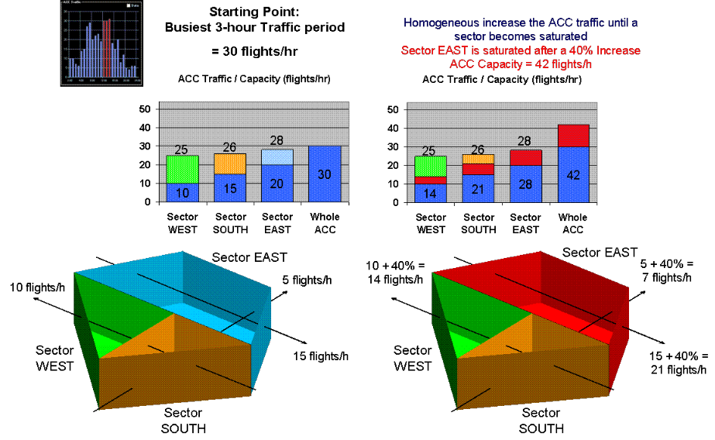

ACCESS
The ACCESS methodology was developed to enable the capacity baseline of non-delay-producing ACCs to be measured using Reverse CASA.
The use of Reverse CASA means that a non delay-producing ACC must be placed in traffic conditions where it produces delay. Therefore to determine the ACCESS capacity indicator for each ACC on a daily basis, traffic is homogenously increased over the whole ECAC area until the delay threshold is reached in the studied ACC.
At each step of the traffic increase, ACCESS creates a new regulation scheme for the studied ACC. This is done using traffic volume capacities and configuration data (sector opening schemes) provided by ANSPs.
The network effect outside the studied ACC will not change, provided that the capacity/ demand ratio remains constant in every sector outside the studied ACC. Therefore, each time traffic changes in the studied ACC, sector capacities outside the studied ACC are increased or decreased in line with the traffic change.
Note that the ACCESS delay threshold per ACC is arbitrary and changing it does not greatly affect overall results; it has no connection to the PC enroute average ECAC delay target of 1 minute per flight.
Figure 5: ACCESS Process
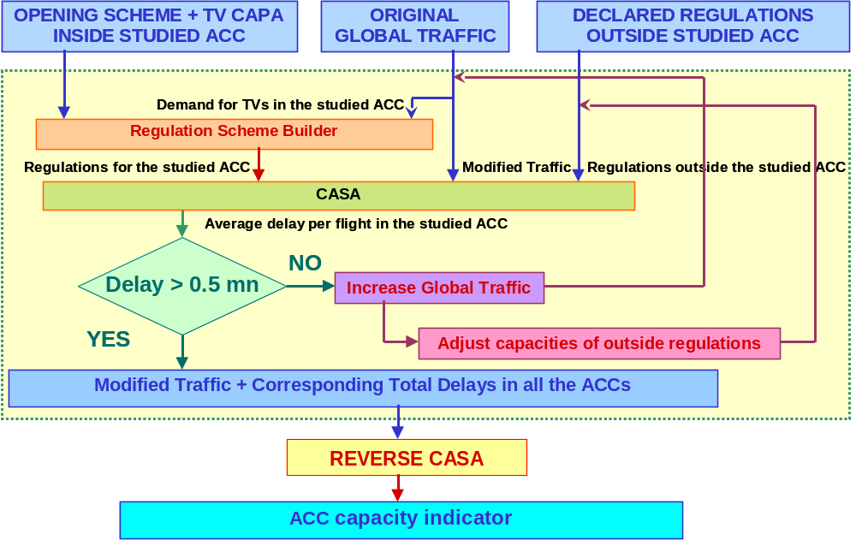

It is important to note that both ACCESS and NEVAC give good results only when the input data (declared sector capacities and configuration opening schemes) are accurate and complete.

Expected Demand on the Future Route Network
Medium-term capacity requirements at ACC or sector group level can only be assessed once we have a picture of the expected traffic volume and distribution over the future route network.
The expected demand at ACC or sector group level is assessed by the FAP tool, from:
- the forecast traffic growth;
- the future route network evolution and traffic distribution, simulated by an airspace modelling tool;
- airport capacity constraints, assessed from information gathered from various sources on current and planned airport capacities.
Figure 6: Assessment of expected demand
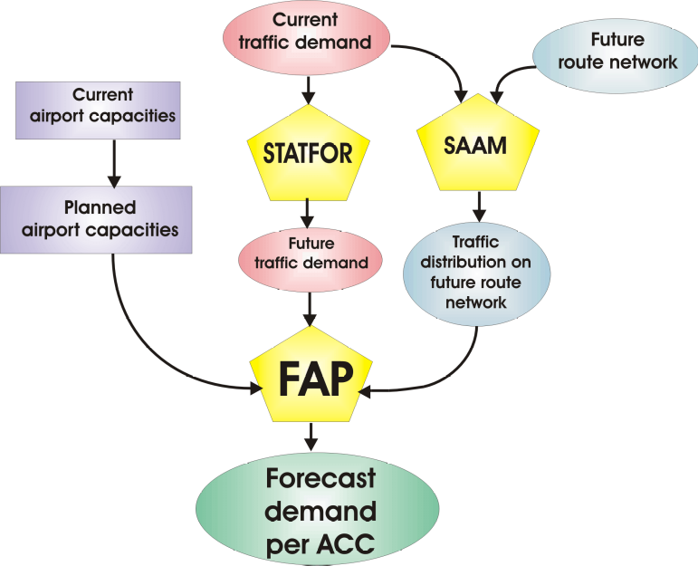

Forecast Traffic Growth
In the western parts of the EUR Region, the EUROCONTROL Statistical Forecasting service (STATFOR) processes air traffic statistics at European and regional level, and produces traffic forecasts. These forecasts take into account different sets of assumptions, e.g. economic growth, airline productivity, competition from other means of transport, as well as the ‘maximum aircraft movements per year’ at congested airports.
The STATFOR medium term traffic forecasts are based on “traffic flows” between a number of Origin/Destination Zones (ODZ). An ODZ corresponds to a major airport or group of airports. STATFOR provides traffic growth forecasts for different ODZ pairs and for the countries overflown. STATFOR models approximately 100 individual ODZ pairs giving around 9000 individual flows.
STATFOR also provides a short term traffic forecast. This, combined with the alternative capacity profiles based on the high and low traffic forecast, enables ANSPs to formulate capacity plans according to local traffic requirements and variations.

Flight Increase Process (FIPS) and Airport capacity constraints
The traffic increase is made within FAP according to the STATFOR forecast, by “cloning” existing flights in such a way as to preserve the daily demand distribution. This is based on the hypothesis that the existing demand distribution represents the desired exploitation (in time) of the various markets served by the airspace users.
STATFOR takes into account the most congested airports in its forecast, through the ‘maximum aircraft movements per year’, but it is important that FAP, when performing the traffic augmentation, has information on major airport hourly capacities.
Valid information on airport capacity, current and planned, is essential for planning the development of the European air traffic system. Attempts to obtain accurate information on airport capacities from local authorities have met limited success but there is an ongoing initiative to improve the quality of airport capacity information used in the FAP model and to fully integrate airports into the capacity planning process. This is being done through wide consultation with ANSPs, airport operators and users.
When faced with demand which is likely to exceed the airport capacity constraints, the FAP model will, through the FIPS process:
- spread peak traffic demand by shifting the creation of new flights, by up to one hour, to a non-saturated period;
- ‘displace’ further new demand to the nearest non-saturated airport available in the same ODZ, that has been identified by the ANSP as a suitable alternative;
- not accommodate further new demand when no alternative airport can be identified in the same ODZ.
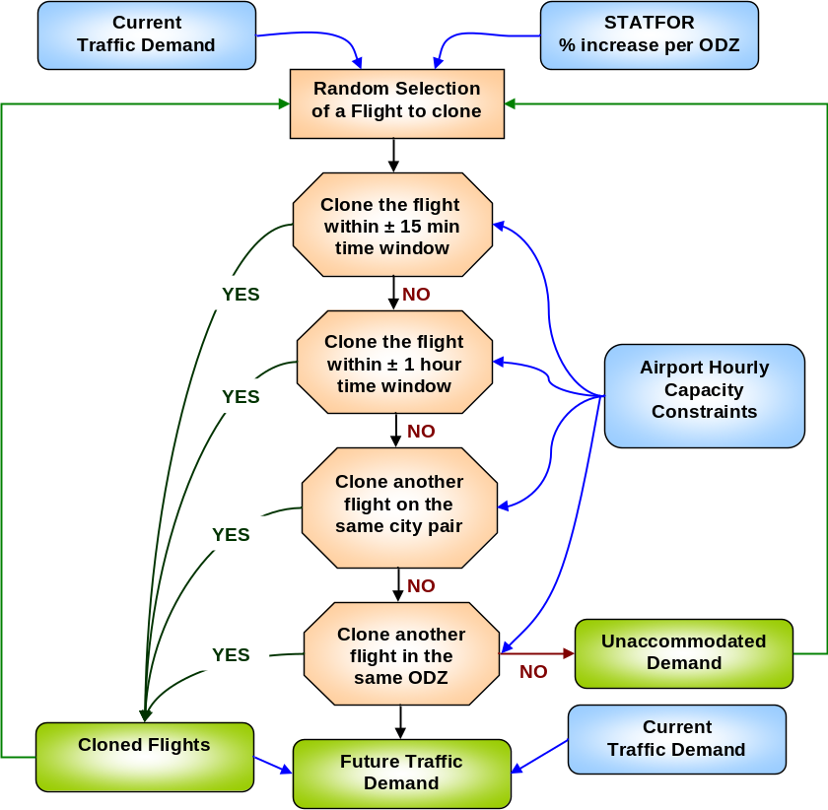
Full integration of major airports into the European capacity planning process will ensure that capacity enhancement measures are implemented where and when they will provide maximum benefit to the European ATM network as a whole; improved accuracy and availability of airport capacity plans will ensure the timely development of airspace capacity enhancement measures (see paragraph 5.2 for more information).
Figure 7: FIPS process

Future Route Network Evolution and Traffic Distribution
The capacity requirement for an ACC or sector group is clearly dependent on the distribution of traffic over the European network, horizontally and vertically. The demand to be accommodated in the future is determined, taking into account the desire of users to fly the most direct routes and optimum vertical profiles, in the context of the anticipated evolution of the route network.
Changes to the route network and traffic distribution can induce significant changes in terms of the demand (and therefore the required capacity) at individual ACCs, even during periods of reduced traffic growth.
It is assumed that aircraft will follow the shortest routes available on the network between city pairs according to the future route network, on essentially unconstrained vertical profiles. Nevertheless, some existing structural traffic distribution scenarios are retained. There is no ‘dispersion’ of flights between equivalent routes between city pairs.
Traffic flows respecting these assumptions are simulated by the SAAM tool, and serve as an input to the FAP simulations. The result of the SAAM simulation is a horizontal and vertical traffic distribution over the future route network, allowing the determination of the unconstrained demand in each ACC.
SAAM can also simulate the effect of aircraft operators choosing to fly the cheapest available routes, but although this information is provided to ANSPs, it is not used in the capacity profile calculation because of the unpredictability of service provision costs beyond the short term. The transition of future demand towards shorter and cheaper routes is likely to have a significant impact in several ACCs and increased interaction with airspace users will allow a better reflection of the expected distribution of the traffic demand on the network.

Cost Data and Economic Modelling
Capacity requirements for the short and medium-term are assessed on the basis of the high-level capacity objective of the ATM2000+ “to provide sufficient capacity to accommodate the demand in typical busy hour periods without imposing significant operational, economic or environmental penalties under normal circumstances.”
The criteria for deciding the level of penalties to be considered ‘significant’ are set by the EUROCONTROL PC, based on the recommendations of the Performance Review Commission (PRC), the Stakeholders Consultative Group (SCG) and of the EUROCONTROL Agency.
Capacity has a cost, but insufficient capacity, which in turn generates delay, has an even larger cost. Both capacity and delay costs are borne by airspace users. It is therefore necessary to determine the level of ATC capacity which can be justified from a cost point of view i.e. the optimum trade-off between delay and cost of ATC capacity.
The delay cost used by FAP is an average of International Air Transport Association (IATA) and PRC data, which FAP employs in conjunction with its knowledge of the traffic mix in order to determine the cost for delay in each ACC. Changing the cost of delay has minimal effect on future capacity requirements because of the stable delay target.
The capacity cost (i.e. the cost for provision of ANS) used by FAP is taken from data provided by the CRCO. This cost is assumed by the FAP model to vary linearly – a fact supported by CRCO analysis and confirmed in the 7th Performance Review Report (PRR7).
While the cost data used is provided by the CRCO, it is essential that each ANSP indicates how this cost is spread among the ACCs under its responsibility.
The cost of capacity and the cost of delay are regional parameters depending on:
- total capacity provided
- marginal capacity cost (ATC complexity, price index, equipment, etc)
- total delay generated
- delay sensitivity (network effects, hourly traffic distribution)
- cost per minute of delay (traffic mix)
Consequently, each ACC has its own capacity cost and delay cost curves. These curves interrelate as network effects change according to changes in capacity offered at other ACCs.
The total cost curve (the sum of the delay cost and the capacity cost) determines the optimum cost model capacity for each ACC for the current traffic demand. However, to assess capacity requirements for the future, it is necessary to incorporate the future demand into the model in an updated total cost curve for each ACC. The following paragraphs describe this process.

5.3.1 Capacity / Delay / Demand interaction and the Cost model
The relationship between capacity and delay is not linear. More precisely, when the demand is close to the maximum available capacity, there is a saturation of the ACC, leading to a very sharp increase in delay.
A simple capacity/delay curve can represent how delay and capacity interact with each other for a given ACC and for a given level of traffic demand.
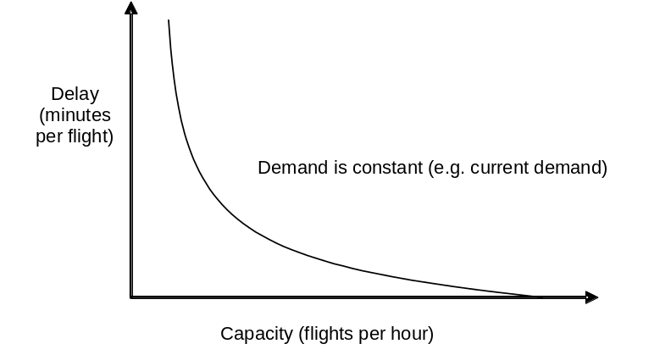

Figure : The Capacity/Delay Curve

This capacity/delay curve is used to elaborate the cost model. For the best trade-off between the cost of delay and the cost of capacity provision, and to ensure consistent targets, economic data are introduced for each ACC, and a total cost curve is derived:
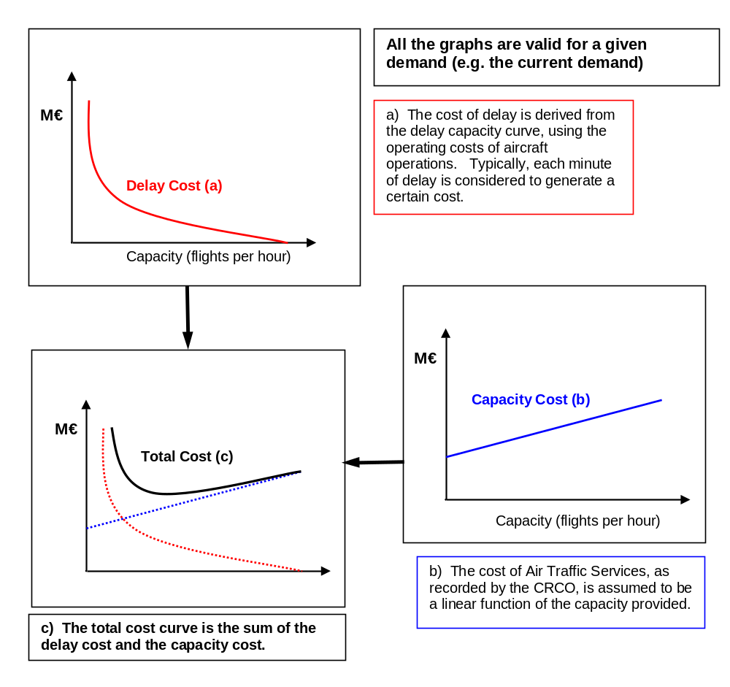
Figure 8: The Cost Model

Optimum Cost Model ACC Capacity
For a given demand, the total cost curve is used to determine the Current Operating Point and the Optimum Operating Point, as represented in Figure 10.
The Optimum Operating Point, which gives the lowest total cost of operation, represents the best trade-off between the cost of providing capacity and the cost of delay. This point represents the Optimum Capacity and optimum delay level (from a total cost point of view) for a particular ACC.
If each ACC were operating at its optimum point, it would correspond to the optimum level of ATFM delay at overall ECAC level.
Figure : ACC Capacity: The Operating Point
Current operating point 2
shortfall
Cost of
shortfall
Cost of
surplus
Optimum operating point
Current operating point 1
M €
Delay cost
Capacity cost
M €
Capacity (flights per hour)
surplus
optimum
The Current Operating Point represents the cost of operating at current capacity.
Either the ACC capacity is above the optimum capacity (Operating Point 1), indicating a capacity surplus, or the ACC capacity is lower than the optimum capacity (Operating Point 2), indicating a capacity shortfall.
The next step is to carry out the economic analysis or cost optimisation for the future traffic demand.

Calculation of the Required Capacity Profiles
After the economic analysis or cost optimisation for the future traffic demand is carried out, the final step in the process takes place. FAP carries out another iterative ATFM simulation by increasing capacity at the ACC offering the best Return on Investment (ROI), until the overall delay target of 1 minute per flight enroute is reached.

Figure : Iterative ATFM network simulations with best ROI to achieve target delay
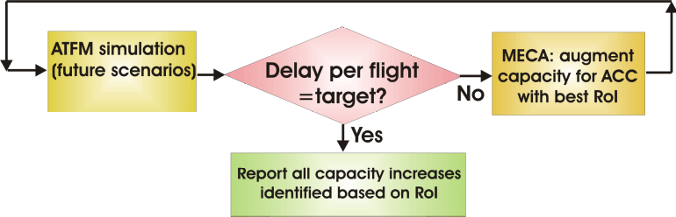
When the agreed target delay is reached, the capacity target for each ACC is expressed in terms of the capacity increase that was necessary in order for the convergence to be achieved. Simulations are carried out for the final year of the planning cycle and for any year that there are changes to ACC or sector group configurations. Capacity levels are interpolated for intermediate years.
The capacity target level corresponds to the cost optimum delay for the ACC, to meet the overall 1 minute average enroute delay target adopted by the PC, and represents the ACC capacity required to cover:
- the expected demand, and (if appropriate),
- the current capacity shortfall, i.e., the difference between the optimum capacity and the current capacity (as described in the previous section).
Figure : Current v. Target capacity
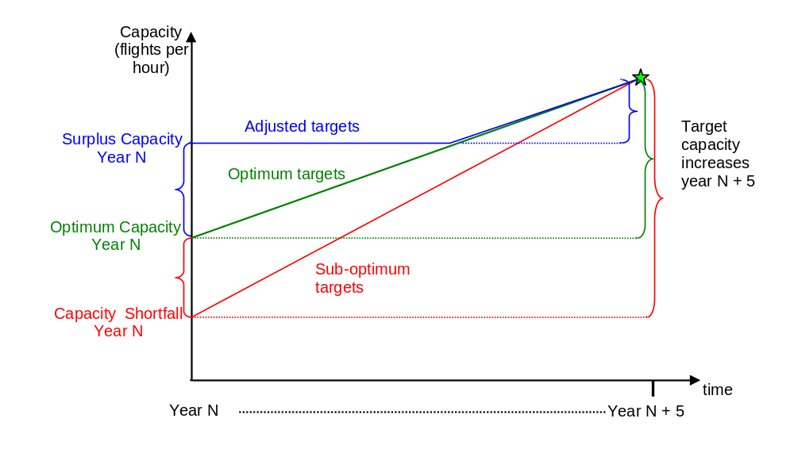

Figure 12 shows an ACC with a capacity surplus (blue), an ACC with a capacity shortfall (red) and an ACC with optimum capacity (green). For the ACC with optimum capacity, the requirement is only to cover the forecast traffic increase. For the ACC with a capacity shortfall, the requirement is to cover both the shortfall and the traffic increase, and for the one with a surplus, the requirement is to achieve the optimum capacity in the medium term, without costly over provision.
In addition to the capacity profile, each Air Navigation Service Provider receives from the Agency the values corresponding to the optimum delay for their ACC/s from a network perspective.
If the network delay is close to the target delay, the optimum delay at ACC level is an effective tool to identify areas that still have a capacity gap.

The Capacity Planning Work Programme
This chapter describes the different phases of the annual work programme and lists the required actions and responsibilities. Details of each event are provided after the table.

Actions, Deadlines and Responsibilities
EVENT | ACTION EUROCONTROL | ACTION ANSPS
Oct- Dec  Capacity Planning meetings for the short- and medium-term | CEF to provide all relevant data to enable the ANSP to prepare a first draft of the local capacity plan  - as data becomes available, &  - at least 2 weeks before the meeting | Prepare the draft capacity plan  - prior to the meeting with CEF
 |  | Ensure the participation of both planning and operational staff at the meeting
Nov - Dec  Completion of the Capacity Plan for the LCIP | CEF to complete the capacity chapter of the LCIP, in coordination with the LCIP Contact Person  - by the end of December | Finalise the capacity plan for the LCIP  - by the end of November
Nov -Feb  ATFM and Capacity Report for previous year developed in coordination with ANSPs and the CFMU | CEF to coordinate and agree with ANSPs the content with respect to the analysis of ACC performance  - by end January | Review and agree the ACC performance analysis content provided by CEF  - by end January
CEF and CFMU to finalise report
- by end February
January  Agreement and development of the medium-term capacity profile scenarios | CEF to prepare the airspace scenario data for profile calculation following coordination with ANSPs  - by end February | Provide CEF with details of configuration changes (planned or proposed) during the 5 year planning cycle for ACCs and requested sector groups  - by the end of January
February  Release of STATFOR Short- and Medium-Term Traffic Forecasts | STATFOR to convene meetings and provide the forum for all relevant information to be included in the Spring forecast  - during the calendar year | To attend the STATFOR user group meetings if possible and if not, to ensure that all information relevant to the traffic forecast is provided to STATFOR  - by the end of December
STATFOR to provide the new Medium-Term traffic forecast
- by the end of February
STATFOR to merge the short- and the medium-term traffic forecasts
- from 2008

EVENT | ACTION EUROCONTROL | ACTION ANSPS
March  Calculation of medium-term capacity profiles (including optimum delay per ACC) | CEF to calculate the optimum delay for each ACC  - by mid March | To agree the capacity profiles and optimum delay per ACC for use as a basis for the local capacity plan  - by end April
CEF to calculate the capacity requirement profiles for ACCs and requested sector groups
- by mid March
March  Calculation of the delay forecast for the coming Summer season and next 2 years | CEF to make the delay forecast for the coming Summer season and the next 2 years  - by mid March | To ensure that the local capacity plan is up-to-date and accurate and to communicate any changes to CEF and the CFMU  - before mid February
March  The annual meeting of the Capacity Planning Task Force | CEF to organise the CaPlan TF, invite contributions, compile the agenda and write the report | To attend the CaPlan TF, with the appropriate planning & operational participation and be prepared to share best practice capacity planning
April  Publication of the Network Operations Plan for the coming Summer Season | CEF to provide a consolidated version of all local capacity plans to the CFMU  - by end February | To ensure that up-to-date capacity information for the coming Summer season is made available, and that any changes subsequent to the release of the LCIP are communicated to both CEF and the CFMU for inclusion in the NOP  - by end February  - as they occur, throughout the Summer season
CFMU to incorporate the Summer capacity plans into the NOP
- by mid March
APN & AOE to provide to the CFMU information relevant to the coming Summer season
- by end February
CFMU to release the first version
- by mid March
May  Coordination and agreement of medium term capacity profiles | CEF to coordinate bilaterally with ANSPs and agree the profiles that will be used as the basis for local capacity planning in the medium-term  - by end March | To inform their SCG/OCG member when the capacity profiles and optimum delay per ACC have been agreed for use as a basis for the local capacity plan  - prior to Spring meeting of SCG/OCG
CEF to present the capacity profiles to the Spring meeting of the SCG/OCG for approval
- May meeting of SCG/OCG

EVENT | ACTION EUROCONTROL | ACTION ANSPS
June  Publication of the European Medium-Term ATM Network Capacity Plan | CEF to collect and consolidate all the local medium-term capacity plans and complete an analysis of the expected situation at network and local level  - by end of April | To ensure that the medium-term capacity plan is accurately reflected in the LCIP and that any subsequent changes are communicated to CEF  - by mid March
July  ECIP published (including ACC capacity requirement profiles) | EUROCONTROL to release document  - by end of July
Jul - Aug  ACC/sector group capacity baseline assessment period | CEF to inform ANSPs of the reference dates and request confirmation of data quality  - by the end of June | To confirm that fully accurate sector capacity and opening scheme data will either be directly provided to CEF or will be available from the CFMU archive database  - 1 week before the reference period
CEF to calculate the ACCESS baselines for ACCs and requested sector groups, according to the airspace structure scenarios defined for the capacity profiles
- by end August
 | In addition to the ACCESS baseline assessment, CEF to calculate the capacity baselines using NEVAC for all ACCs and using Reverse CASA for those ACCs that generate ATFM delay  - by end August | To ensure that the sector capacity and opening scheme data within the CFMU database is sufficiently accurate for the NEVAC baseline assessment  - two AIRAC cycles before the start of the AIRAC containing the measurement period
Sep - Oct  ACC capacity baselines coordinated with the ANSPs | CEF to communicate the baseline results to ANSPs on a bilateral basis for discussion and agreement  - By mid September | To agree the capacity baselines for the next planning cycle and to inform the SCG/OCG representative  - prior to SCG/OCG Autumn meeting
Sep - Oct  ACC capacity baselines coordinated with the ANSPs | CEF to present the agreed ACC baselines to the Autumn meeting of SCG/OCG  - October meeting of SCG/OCG

Capacity Planning Meetings
Each Autumn, the EUROCONTROL Agency’s Capacity Enhancement Function visits the majority of ANSPs to collect information on capacity plans for the next five years and the coming Summer season. It is essential to the improvement of ATM capacity at overall network level for each ACC to have a robust capacity planning process and a realistic capacity plan.
ANSPs that are responsible for ACCs operating at or close to capacity limits are visited each year, with others being visited on request, or when their capacity situation changes.
ANSP capacity plans for each ACC are published in the LCIP, together with other relevant capacity information (e.g. capacity delivered during the previous Summer season, future capacity requirements, expected performance in the medium term and the current and expected capacity of major airports).
Prior to each meeting, CEF provides the ANSP with a set of data to enable them to prepare the preliminary capacity plan, tailored to local conditions. The data set includes the following:
- A report and analysis of capacity delivered during the previous Summer season
- The value of the (Summer) capacity baseline indicator for each ACC and requested sector group
- The optimum delay for each ACC, to meet the network target delay
- A set of 5-year ACC capacity requirement profiles for high, low and medium traffic growth (shortest available routes over the future route network) and for the current route network
- Similar capacity requirement profiles for requested sector groups
- Detailed medium-term STATFOR traffic forecast
- The latest STATFOR short-term traffic forecast per State
- Short and medium-term delay forecast for each ACC
- Differences in demand between current routes and shortest routes and current routes and cheapest routes scenarios
- Other relevant capacity information
ANSPs prepare a first draft of the capacity plan for the meeting, which is discussed and updated in an interactive session, using the NEVAC and SAAM tools. To facilitate the discussion and ensure a realistic capacity plan, ANSPs should ensure the presence of both planning and operational staff.
The plan should detail the capacity enhancement actions planned each year of the capacity planning cycle, together with a realistic assessment of the contribution of these initiatives to the overall annual capacity increase. Full guidance for formulation of the plan is given in Annex F: The Capacity Plan.
After the meeting, CEF completes the capacity chapter of the LCIP, in coordination with the EUROCONTROL LCIP contact person. Once approved by the ANSP, this is incorporated into the LCIP, which is then approved and signed at State level.

ATFM and Capacity Report
This annually released document provides information and analysis of the traffic in Europe, the delays derived from Air Traffic Flow Management for ACCs and airports, and the capacity offered by the ANSPs during the previous calendar year. It is jointly compiled by CEF and the CFMU.

Capacity Profile Scenario Development & Agreement
The number of capacity profile simulations that have to be run is linked to the number of changes to airspace structure planned during the 5 year period and to the overall network target delay. In a totally stable environment, both would remain the same and it would be necessary to evaluate only one scenario. However, this is rarely the case – either ACC configurations are planned to change, or the delay target changes over the period.
CEF needs to complete a comprehensive data preparation before the end of February, so that the simulation can be run as soon as the new STATFOR medium-term traffic forecast is available. ANSPs must therefore provide to CEF, before the end of January, detailed information concerning configuration changes that are planned or proposed within the next 5 years.

STATFOR Medium-Term Traffic Forecast
STATFOR publishes an updated Medium-Term traffic forecast each year at the end of February. Prior to release, the STATFOR user group (comprising various EUROCONTROL units, ANSPs, airport operators, users, user groups) meets to discuss and incorporate any issues that may affect the forecast.
STATFOR will merge the short and medium-term forecasts from 2008, to avoid the confusion of having two different growth values forecast in the same year. This will provide a more stable planning environment.

Medium-Term Capacity Profile Calculation
The capacity profile calculation is made as soon as the STATFOR medium-term traffic forecast is released. A range of capacity profiles are calculated for each ACC / sector group and percentage increases are linked to the capacity baselines that were assessed the previous Summer. The optimum delay per ACC is also calculated.
Note that if the capacity requirement profile is below the capacity baseline for the whole of the planning cycle, there will never be a recommendation for an ACC to reduce capacity, but rather to avoid further costly investment.

Delay Forecast
The delay forecast for the coming Summer season and for the next 2 years is calculated by CEF as soon as the STATFOR forecast is released. It is based on the medium-term traffic forecast and the ACC capacity plans (taken from the LCIP, as well as subsequent updates brought to the attention of CEF).

Capacity Planning Task Force
The capacity planning task force (CaPlan TF) is chaired by the Capacity Enhancement Manager and comprises ANSPs (planning & operational staff), aircraft operator user groups and interested EUROCONTROL units (e.g. CFMU, APN, STATFOR, AOE, PRU). The CaPlan TF meets once a year in the Spring to discuss the results of the previous year’s baseline & profile calculation, proposed improvements to the capacity planning process and to the capacity planning toolset, and to enable participants to share capacity planning best practice.

Network Operations Plan (NOP), Summer
All available information relevant to the coming Summer season is provided in this one document produced by the Agency. It is the result of a coordinated effort by several EUROCONTROL units, ANSPs, airports, airspace users and the military. A living document, it is released by the CFMU in March and updated on-line throughout the season.
CEF consolidates all the local capacity plans for the coming Summer season and provides this information to the CFMU in a format suitable for inclusion in the NOP. ANSPs should notify all subsequent changes to Summer capacity plans to both CEF and to the CFMU for incorporation into the NOP, which is a living document, amended throughout the Summer season.

European Medium-Term ATM Network Capacity Plan
This document, developed in the context of DMEAN, provides a medium-term outlook of the capacity situation, by comparing the capacity requirements with capacity enhancement measures planned at network and ACC level. The plan identifies potential bottlenecks and gives an early indication to States and ANSPs of the need to plan for additional resources, of network interactions and of the need to implement improvements at network level.

Capacity Baseline Assessment
- Derivation of ACCESS capacity baselines for the Summer
The reference period for the assessment of the capacity baselines takes place over 2 weeks during the period mid July to mid August. The actual dates are decided by CEF each year and communicated to ANSPs by the end of June.
The achievement of reliable results using the ACCESS methodology requires high quality input data on actual opening schemes and sector capacities during the stated period. It is essential that at least 1 week before the assessment period, ANSPs:
- positively confirm that the data available at CFMU during the reference period will be of the required standard, and may be extracted for ACCESS measurement, or, if this is not the case,
- ensure that a process is in place at the ACC, to collect data of the required standard for each day of the reference period, if possible using NEVAC.
In NEVAC it is possible to insert, as a scenario, the actual opening scheme and the real capacities used during the measurement period. These scenarios can then be exported in a Excel file and sent to CEF by email.
Alternatively, the information can be provided using Excel (see the example below). Note that one spreadsheet should be provided for each ACC (or sector group) assessed, for each day of the simulation period (e.g. for 1 ACC and 1 sector group, there would be 28 sheets).

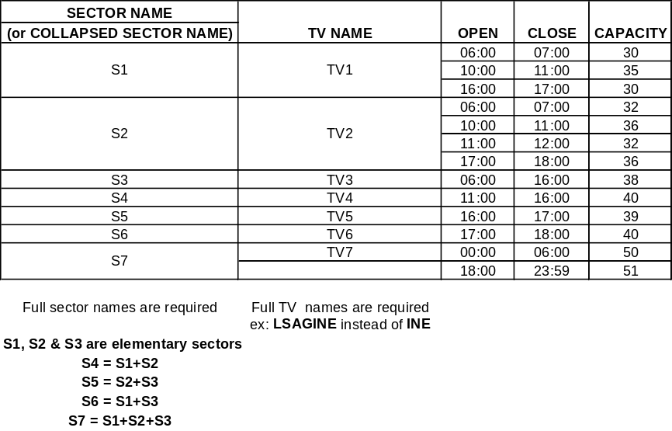

- Derivation of capacity baselines with NEVAC and Reverse CASA
The derivation of capacity baselines with NEVAC (previously PACT) and Reverse CASA will continue until the ACCESS methodology has been fully validated. This monitoring period will ensure that the ACCESS methodology is consistent and that results are coherent and reliable, even when an ACC changes from one that does not generate delay, to a delay-producing ACC. ANSPs should ensure that the sector configuration and capacity data held in the CFMU database is accurate for NEVAC baseline assessment.

Capacity Planning – the broader view

A prime objective of the Dynamic Management of the European ATM Network (DMEAN) programme is to reduce the network level of delay. The Summer delay target set by the Provisional Council in 2000 is applicable only to enroute delay which had been increasing year on year, whereas airport delay had remained more or less constant.

The structured capacity planning process in place for ACCs has shown benefit through a reduction in enroute ATFM delay to close to target levels, and a year-on-year increase in the effective capacity of the European network.

By Summer 2006, compared to Summer 2000, enroute ATFM delay had dropped by 54% for a traffic increase of 15%.

Nevertheless, in 2005 and 2006, both enroute and airport delay again increased and it became apparent that enroute capacity planning should be further strengthened and that airports should be fully integrated into the capacity planning process.

Enroute
Following the consultation and approval process, the ACC capacity requirement profiles are used by ANSPs as a basis for their local capacity plans. The range of profiles provided by the Agency (high, medium & low traffic growth, using shortest routes on the future route network and medium traffic growth using current routes), together with the STATFOR short term traffic forecast, allows the ANSP to plan according to specific local conditions and traffic growth.

The enroute capacity planning process is mature and fully accepted by ANSPs. The Agency provides a sophisticated toolset and full support to ANSPs for the formulation of the local capacity plan (see Annex D).

Future Developments
The enroute capacity planning process is continually being refined. Planned improvements include the merging of the short and medium term traffic forecasts and the further development and consolidation of the demand & airspace data repository. These improvements will enable better analysis of the benefits of capacity enhancement initiatives prior to implementation.

Demand / Airspace Data Repository
The database will allow users to select archive or future traffic samples for a particular date and airspace, at State, ACC or sector level. Historical data will be CFMU archive data and forecast traffic samples may be distributed over either the current or the future (planned) route network and airspace structure, drawn from CFMU, STATFOR and SAAM data. ANSPs will have the additional facility to make changes to sector boundaries and configurations and to test proposed improvements prior to fast- or real-time simulation.

The data will be available for download in a format suitable for analysis using the tools commonly used in the airspace development and capacity planning process (e.g. NEVAC, SAAM).

Airports
Until recently, airport capacities were taken into account only with respect to the constraints that congested airports place on the capacity of the enroute network. This was in part due to the fact that airport delay had remained more or less constant and partly due to the difficulty of coordinating with so many different stakeholders – airport operators (usually independent, commercially driven), Air Traffic Control, and various aircraft operators and user groups.
Nevertheless, an airport must engage in airside capacity planning to meet future demand and sustain growth. Airports are being integrated into the capacity planning process, requiring more visibility of future capacity planning. The primary objective of this process is to provide a structure for identifying and targeting the constraints that limit current or future capacity.

Airside Capacity Planning
This dynamic (rolling five year) process starts by identifying the possible imbalance between demand and capacity and then determining which constraints impact the airports ability to remedy this situation. The process maps current and forecast traffic demand against known constraints, and incorporates information on all areas associated with the development of the airport's airside. To ensure that this information is accurate and reliable, key stakeholders from all areas of the airport are involved, including as a minimum airlines, apron control, ATS provider and airport operations.
The benefit to the ATM network of airside capacity planning in the medium term (5 to 7 years) is reduction of reactionary delays, due to airports’ improved capability to meet future traffic demand

.
Capacity at a number of airports is at a premium and action is needed to ensure that intrinsic system capacity is not superseded by demand at a particular moment on the day of operations.
Provided that airport stakeholders accept the capacity declaration process, based on an accurate capacity assessment and have an efficient slot monitoring process in place, then in normal conditions slot regulations should be a rare event. However, experience indicates that regulations and delays are a daily reality, even in normal conditions.

Airport delay should not be considered in isolation nor disassociated from airside capacity issues in general nor in particular from the runway capacity declaration process which is a critical element. Providing sufficient airside capacity is a key element in any airport delay reduction process.

Delay Reduction Initiative
The EUROCONTROL Airport Operations and Environment business division (AOE) has developed a structured delay reduction initiative as the platform and rational link towards capacity enhancement initiatives, as there is little point in trying to enhance capacity or efficiency without analysing the real reasons for delay. Bringing former planned activities into the context of delay reduction supports the DMEAN activities, because of the unique relationship between delay and capacity.

Delay reduction and capacity enhancement measures focus initially on releasing airside capacity in the short term, and should enable committed stakeholders to meet capacity demand in the medium term.

The resulting Capacity Enhancement Action Plan for the respective stakeholders includes short, medium and long term activities and aspects, and ensures continuity and a smooth transition between short and medium term phases.

The most-constraining airports identified within the European Network are selected for delay analysis, with respect to:
- the historic evolution of delays from 2000 onwards, and
- the actual reason(s) for delays.
The following specific issues are considered:
- What is meant by ATC/Aerodrome delays? (The capacity declaration should reflect ATC/Aerodrome limits.)
- Who is involved in the capacity declaration process and is there buy-in from all stakeholders?
- What are the reasons for excess traffic over and above the capacity declaration?
- How is extra traffic such as General Aviation accommodated?
- How many off-slot operations are there and how are these dealt with?
- Is there an efficient slot monitoring committee?

The DMEAN Airport Implementation Coordination Group coordinates the airport capacity enhancement activities. This group includes:
- concerned EUROCONTROL units, including the CFMU, eCODA, Airspace, Network Planning & Navigation business division (APN), the Capacity Enhancement Function (CEF) and the Airport Operations and Environment business division (AOE),
- the Performance Review Unit (PRU),
- IATA,
- ACI, and
- EUACA

The DMEAN Airport Implementation Coordination Group has agreed on the following coordinated activities planned for the short- and medium-term, for the most constraining airports:
- Capacity Enhancement Exercises,
- Delay Analysis,
- Capacity/Demand Ratio Planning, and
- Airport Collaborative Decision Making (A-CDM) gap analysis and implementation

Capacity/Demand Ratio Planning
Although annual airside capacity has no operational value, as with enroute ACC capacity, it is very important for planning purposes. Some airports publish detailed analysis of demand and capacity, taking into account hourly and seasonal variation. For others, starting from the hourly declared capacity, it should be possible to identify and define available practices to determine annual declared capacity.
The Agency collects and identifies the medium term annual demand forecast data from selected airports. The capacity/demand ratio is computed on a yearly basis for the three traffic growth scenarios (STATFOR baseline, high, low) and presented graphically to visualise the trend and anticipate any lack of capacity in the medium term.

Airport Collaborative Decision Making (A-CDM)

The concept of Airport CDM brings together all the main airport partners (ATC, airport operator, airlines, CFMU and ground handlers), to share operational data in a transparent way and achieve common situational awareness. Enhanced decision making processes lead to maximum operational efficiency and best use of the available airport infrastructure and resource management.
Airport CDM is a low cost and efficient solution to many of the issues facing airports. EUROCONTROL has produced a comprehensive implementation manual providing guidance for understanding Airport CDM and initiating a local CDM implementation project, covering project management and implementation as well as all elements of Airport CDM,: information sharing, turn-round process, variable taxi-time calculations, collaborative management of flight updates, pre-departure sequencing and CDM in adverse conditions.

List of Acronyms

ACC: Area Control Centre
SCG: Stakeholder Consultation Group
AIRAC: Aeronautical Information Regulation And Control
ANS: Air Navigation Services
ANSP: Air Navigation Service Provider
ARN: ATS Route Network
ATC: Air Traffic Control
ATFCM: Air Traffic Flow and Capacity Management
ATFM: Air Traffic Flow Management
ATM: Air Traffic Management
ATM 2000+: EUROCONTROL ATM Strategy for the Years 2000+
ATS: Air Traffic Services
CAMACA: Commonly Agreed Methodology for Airport Capacity Assessment
CAPAN: Capacity Analyser
CASA: Computer Assisted Slot Allocation
CEF: Capacity Enhancement Function
CEM: Capacity Enhancement Manager
CESC: Chief Executives Standing Conference
CFMU: Central Flow Management Unit
CP: Contact Person
CRCO: Central Route Charges Office
CTOT: Calculated Take Off Time
DMEAN Dynamic Management of the European Airspace Network
DOp: Directors of ATS Operations Meeting
EAG: EUROCONTROL ATFM Group
EATM: European ATM
ECAC: European Civil Aviation Conference
ECIP: European Convergence and Implementation Plan
EEC: EUROCONTROL Experimental Centre
EOBT: Estimated Off-Block Time
ETFMS: Enhanced Tactical Flow Management System (ETFMS)
FAP: Future ATM Profile (set of simulation tools for capacity evaluation)
FIPS Flight Increase ProcesS
FMD: Flow Management Division
FMP: Flow Management Position
GASEL: Generic ATFM Simulator Engine & Library (FAP component)
IATA: International Air Transport Association
ICO Improved Configuration Organiser
LoA Letter of Agreement
LCIP: Local Convergence and Implementation Plan
MECA: Model for Economical evaluation of Capacities in the ATM system (FAP)
NEVAC: Network Estimation & Visualisation of ACC Capacity
NORVASE: Tool to establish the criteria for determining sector capacities (NORmativa VAlidacion SEctores (AENA)
ODZ: Origin /Destination Zone (STATFOR)
P1H Peak one Hour (demand)
P3H: Peak three Hour (demand)
PACT: Portable ACC Capacity evaluation Tool
PC: Provisional Council
PIATA: Performance Indicators Analysis Tool for Airports
PICAP Runway Capacity Research Programme (Programa de Investigacion de Capacidad de Pista (AENA)
PRC: Performance Review Commission
PRU: Performance Review Unit
RAD Route Availability Document (published by CFMU)
RAMS: Reorganised ATC Mathematical Simulator
ROI: Return on Investment
SAAM: System for traffic Assignment and Analysis at Macroscopic Level
SIMMOD: Airport and Airspace Delay Simulation Model
SIS: Stakeholders Implementation Service
STATFOR: Statistics and Forecasting
TAAM Total Airspace and Airport Modeller
TACT: CFMU Tactical system
UAC: Upper Area Control centre

Commonly Understood Definitions
Elementary Sector: Primary component of the airspace structure, one or more of which may be combined to form a sector. In some cases the elementary sector can be the same as the operational sector; in other cases, the elementary sector is never open operationally without being combined with one or more other elementary sectors.
Sector: Primary operational component of the airspace structure that can be considered as an elementary capacity reference of the ATM system. A sector is made up of one or more elementary sectors.
Sector Group: Group of sectors that strongly interact with each other through close and complex coordination, satisfying the DMEAN concept of operations.
Traffic Volume: Airspace component based on traffic flow, that serves as a reference to design the ATC sectors.
Sector capacity: The maximum number of flights that may enter a sector per hour averaged over a sustainable period of time (e.g. 3 hours), to ensure a safe, orderly and efficient traffic flow. Some ANSPs manage sector capacities tactically over a shorter period of time (e.g. 15 minutes). However, for global assessment purposes, the hourly figure is used as standard.
Declared Sector Capacity or Monitoring Value: The value the ANSP declares to the CFMU as the maximum number of flights per hour that can enter a sector before the application of an ATFM regulation becomes necessary. Several values may exist - depending on the ATC environment at the time (airspace, equipment, traffic pattern, staffing, weather etc.). The FMP defines this information and advises the CFMU, so that it can provide the ATFM service. The value can change according to the situation at the ACC.
Declared Traffic Volume Capacity: The capacity for a given period of time for a given traffic volume, as made known by the ANSP to the CFMU, so that it can provide the ATFM service. As with Sector Capacity, the value can change depending on the ATC environment at the time at the ACC.
ACC/ Sector Group Capacity: The theoretical maximum number of flights that may enter an ACC or sector group per hour, over a period of time (e.g. 3 hours), without causing excessive workload in any of the sectors. This capacity indicator is used for capacity planning and monitoring purposes and has no operational value. The indicator is calculated mathematically using a validated methodology.
Capacity Baseline: The value of the capacity indicator (see above) for the ACC and defined sector groups
Capacity Profile: The evolution of required capacity over the five-year planning cycle, considering certain assumptions, for a specified volume of airspace (ACC or defined sector group), in terms of absolute demand (flights per hour) and annual percentage increases. These values are published annually in the ECIP and are used as a basis for local capacity planning by ANSPs.
Network Effect: The network effect is the phenomenon where regulations placed on parts of the network affect the demand structure observed in other parts of the network. Network effects range from simple interactions of cause and effect, to more complex interactions between groups of sectors, where causes are repeatedly re-triggered by effects, involving several oscillations before a stable equilibrium is reached. Affected sectors could be adjacent, in the same region, or distant sectors located on the far side of the ECAC zone.

The Capacity Planning Calendar

DATE | MAIN EVENTS
Oct- Dec | Short- and Medium-Term Capacity Planning meetings with ANSPs
Nov -Jan | ATFM and Capacity Report for previous year developed in coordination with ANSPs and the CFMU
Jan | Agreement and development on the medium-term capacity profile scenarios
Jan - Mar | European ATC Capacity Plan for coming Summer season finalised
Feb | Publication of ATFM and Capacity Report developed jointly with the CFMU
Feb | Release of STATFOR Medium-Term Forecast
Mar | Calculation of medium-term capacity profiles (including optimum delay per ACC)
Mar | Calculation of the delay forecast for the coming Summer season and next 2 years
Mar | The annual meeting of the Capacity Planning Task Force
Mar | Publication of the Network Operations Plan for the coming Summer Season
May | Coordination and agreement of medium-term capacity profiles
Jun | Publication of the European Medium-Term ATM Network Capacity Plan
Jul | ECIP published (including ACC capacity profiles)
Jul-Aug | ACC/sector group capacity baseline assessment period
Sep-Oct | ACC capacity baselines coordinated with the ANSPs
Oct | Capacity baselines agreed and presented to stakeholder consultative groups

EUROCONTROL Support for Local Capacity Planning

European capacity planning is a fully cooperative process between EUROCONTROL, States, ANSPs, airspace users and other stakeholders.
To facilitate coherent medium term planning, EUROCONTROL monitors capacity offered at local and network level and provides support and assistance to ANSPs and airports for capacity assessment and planning. A number of tools have been developed and are available to ANSPs.

Support Services
The ECIP is published annually in two parts:
- The ATM Implementation Perspective, which sets out the operational, technical and institutional improvements that have to be applied to the European ATM network to meet clearly defined performance requirements in certain key ATM performance areas – safety, capacity, cost-effectiveness and the environment.
- The Detailed Objective Descriptions part describes each of the pan-European, multi-national and harmonisation implementation objectives and the associated stakeholder lines of action. Each objective is linked to one or more of the operational improvements contained in the ATM2000+ Strategy.
The range of 5-year ACC capacity profiles that serve as a basis for the local medium-term capacity plan are published in the ECIP ATM Implementation Perspective.
The LCIP provides a mechanism to align national ATM planning with specific ECIP objectives concerning safety, capacity and cost-effectiveness. With respect to capacity, ANSPs indicate in the LCIP their planned capacity enhancement measures, and quantify the expected annual capacity increase.
The Capacity Enhancement Function (CEF) initiates the consultation process by visiting ANSPs and ATC units, to discuss capacity enhancement measures, best practice and other means to optimise and/or increase capacity at local level. Comprehensive data on past performance and future traffic growth and distribution is provided to ANSPs in advance, and the capacity plan is finalised in a fully interactive session, using the capacity planning and assessment tools available (NEVAC, SAAM).
In addition to the capacity planning meetings in the Autumn, CEF can provide fully interactive NEVAC/ SAAM tutorials focussing on specific ACCs. ANSPs should request such assistance directly with CEF through the Capacity Enhancement Manager, Mr Razvan Bucuroiu razvan.bucuriou@eurocontrol.int .
The Airport Operations and Environment (AOE) business division can provide assistance with capacity assessment and enhancement for airports. This should be requested directly with AOE through Mr Gregory de Clercq, gregory.de-clercq@eurocontrol.int
Implementation support is available from the EUROCONTROL Stakeholder Implementation Service (SIS), and should be requested through the designated LCIP Contact Person.

Support Tools

2.1 Computer Modelling
The EUROCONTROL Agency has tools to address the issues of route network and airspace (including sectorisation) design, the distribution of traffic both in the air and at the airport and the assessment of capacity.
    - NEVAC: Network Evaluation & Visualisation of ACC Capacity
NEVAC is a EUROCONTROL software application, using data from the CFMU and STATFOR and integrating PACT, FIPS (Flight Increase Process) and ICO (Improved Configuration Organiser). NEVAC is able to compute ACC capacity indicators, to detect bottleneck sectors and to evaluate the effect of new configurations or changes to sector capacities on the capacity of an ACC and on the network.
NEVAC has been released for use by planners, capacity managers, flow managers and operational staff responsible for managing ACC and Network capacity. It can:
- Visualise ACC related data (demand, sector / TV capacities, configurations, delay, routes etc.)
- Optimise configuration opening schemes using ICO
- Calculate future traffic samples with FIPS
- Measure protection and penalisation network interactions
- Create virtual ACCs and evaluate airspace reorganisation options between groups of ACCs
- Calculate ACC baseline capacities for a given period
- Perform detailed analysis of demand structure, network interactions, configuration suitability, saturation and ATFM delay all of which affect ACC capacity
- Analyse ACC demand in terms of its structure, load distribution and constituent flows
NEVAC has been extensively tested on the following operating systems: Windows 98, 2000 and XP. Microsoft Excel version 2000 or higher is required (included in Office 2000). Minimum system requirements: Pentium 2, 128 MB RAM, 50 MB free hard disk space. Required free hard disk space depends on how many databases you wish to work with at any one time - 60 MB is sufficient for 2 to 3 AIRAC cycles.
A full description of NEVAC methodology is given in the Quick Start User Guide, accessible via the website www.EUROCONTROL.int/nevac
Questions? Send an email to nevac@EUROCONTROL.int

    - SAAM: System for traffic Assignment & Analysis at a Macroscopic level
SAAM is a European Airspace Design Evaluation tool developed by EUROCONTROL. It is used to model, analyse and visualise route network and airspace developments with current or future traffic data, at local, regional and European-wide levels. SAAM is an integrated system for wide or local design, evaluation, and 2, 3 or 4D presentation of air traffic airspace scenarios and traffic distribution. SAAM is a quick strategic airspace modeller that can be used for preliminary survey, for testing and analysing various options and for preparation of scenarios to be exported to fast-time and/or real-time simulators.

    - CAMACA: Commonly Agreed Methodology for Airport airside Capacity Assessment.
CAMACA is a model developed by EUROCONTROL, that enables measurement and correlation of airport potential (runways, taxiways, aprons and stands) in terms of capacity and demand.

    - PIATA Plus: Performance Indicators Analysis Tool for Airports.
PIATA Plus is a PC-based software model developed by EUROCONTROL that provides a way of analysing efficiency indicators to aid management decisions, improve runway throughput, and enhance airside capacity.

    - PICAP: Runway Capacity Research Programme (Programa de Investigacion de Capacidad de Pista
PICAP is a system developed by AENA to determine the runway capacity at an airport

  - Simulation Tools
While addressing the macroscopic needs, the above models raise issues requiring answers from a different type of model; towards the microscopic end of the scale, fast time models can be characterised as either Air Traffic Flow models or ATM models. The distinction is subtle but significant.
The flow models have been developed specifically to assist the CFMU in its task and future development. In this case the traffic is passing through well known and defined airspace structures.
The ATM models have been designed to help ANSPs plan and develop the ATC issues. Changes to airspace structure, ATC procedures and systems can be fully assessed through fast-time simulation.
    - Generic ATM Simulator Engine & Library GASEL
GASEL is an arithmetical simulator adapted to strategic and pre-tactical studies and simulations in the fields of airspace design, airspace management and ATFM. It replaces the AMOC and COSAAC simulators, and is used:
- to undertake macroscopic studies on the enroute ATC and airport infrastructure, demand patterns and capacity issues in order to assess the overall performance of the air traffic management system;
- to conduct studies on the optimisation of the current flow management system, define and evaluate new concepts for flow management and control;
- to undertake economic and institutional studies on the ATM system.

GASEL functionalities are:
- Traffic increase or decrease
- Capacity baseline computation
- ACC Capacity profiles evaluation
- Delay forecast
- Statistical computation
- Traffics comparison
- Traffic smoothing
- Data transformation

The following functionalities of COSAAC are included:
- Flow selection
- Rerouteing
- Profiling
- Operational disturbances
- Flow growth

    - CAPacity ANalyser (CAPAN) and Reorganised ATC Mathematical Simulator (RAMS)
The ATM models have been designed to help assist ANSPs plan and develop the ATC issues, i.e. refine the airspace design, build the sectors, describe the procedures and explore the impact of new tools. Examples of these models are the Capacity Analyser (CAPAN) and Reorganised ATC Mathematical Simulator (RAMS), for en-route aspects. All of these help define the throughput of a given piece of airspace or an airport and hence the capacity under given conditions.

Many of the analytical and Fast Time models are available in support of EATM within the Capacity Enhancement Function, the Airport Throughput Programme, the Airspace & Flow management and Navigation Business Division and the EUROCONTROL Experimental Centre (EEC).

    - Total Airspace and Airport Modeller TAAM
TAAM is the only commercially available gate-to gate simulator of full-scale airspace and airport operations. The Total Airspace and Airport Modeller can simulate high volumes of air traffic in great detail. The simulator realistically reproduces all ground movements until take-off. All phases of a flight then follow: from take-off through large portions of controlled or uncontrolled airspace to landing and ground movements after arrival.

    - Airport and Airspace Delay SIMulation MODel (SIMMOD™)
An industry standard analysis tool used by airport planners and operators, airlines, airspace designers, and air traffic control authorities for conducting high-fidelity simulations of current and proposed airport and airspace operations. SIMMOD™ is designed to "play out" airport and airspace operations within the computer and calculate the consequences of potential operating conditions. It has the capability and flexibility to address a wide range of "what if" questions related to airport and airspace capacity, delay, and efficiency.

    - NORVASE (NORmativa VAlidacion SEctores)
NORVASE is a tool developed by AENA that establishes criteria for the determination of sector capacities using standardised procedures and specific software to optimise the design and efficiency of the control sectors. NORVASE records real data captured directly in the control position, including all the control and communication actions between sectors carried out by the executive controller and/or planner.
From the processing of the above information, the following data is obtained:
- Statistics of the control actions and
- Workload and capacity (movements/hour),
This information is analysed by a group of ATM experts (air traffic controllers and aeronautical engineers).

    - STANLY The STatistic and ANaLYsis) programme
STANLY is a management information system developed by DFS to represent operational processes. According to the DFS requirements for traffic analysis and statistics, STANLY acts as a master system that gathers flight plan and radar data and combines them logically with the current airspace and meteorological data. This results in an up-to-date picture of the traffic situation over Germany and the neighbouring regions and airports.

  - Real Time Simulation
Real time simulation offers an important opportunity for operational controllers to interact with the ideas modelled and confirm the validity of the approach chosen. Usually 2 or 3 options from the fast-time simulation results are tested in a real-time simulation and it is here that the clearest indication of the possibility to realise the forecast capacity increase is seen.

Airspace groupings for capacity assessment

When performing a performance prediction it is necessary to consider the evolution of both the information quality and the reactionary power within the planning time horizon.
In the short term, the potential for modification to the ATM system is usually limited to a better use of already existing resources using the current system configuration i.e. existing sector configurations and traffic flows. (low reactionary power). Possible improvements can normally be predicted with a high level of confidence (high information quality).
As the planning time horizon extends to the medium term (typically 5 years), it is possible to consider more radical actions such as revised airspace structure, use of improved ATM technology and additional controllers. In this case, there is more scope for change (high reactionary power), although the information quality is necessarily lower, because of the uncertainty associated with the timing of the availability of additional resources and technology.
Short term
1-2 years
Medium term
3-5 years
Long term
5-20 years
Information quality
Reactionary Power
Planning time horizon

Enabler

Figure 3: Short v. Medium Term Planning

Therefore, in the medium term, it may no longer be pertinent to report performance predictions at the level of the existing sector configuration.
It may also be the case that certain airspace structures currently in force may not be appropriate for use in medium term. For example, the closure of the Kosovo airspace means that the route structure in place does not provide a relevant baseline for future performance prediction.
The granularity of the analysis is reduced as the planning time horizon increases, so it becomes more logical to provide predictions at the level of the ACC or at sector group level.

In the medium term it is necessary to explore a wider range of scenarios in terms of traffic growth rates and evolution of the ATM infrastructure. These different levels of analysis granularity have given rise to FAP concepts such as ACC capacity and the capacity demand ratio.
The notion of ACC capacity is not an operational one, but was developed to:
- monitor ACC performance year on year (by comparing historical and current data);
- measure ACC plans against future capacity requirements (ACC capacity profiles are assessed by FAP according to forecast demand and agreed parameters;
- support local capacity planning
- give a managerial review in terms of future expectations and associated resources.
The ACC capacity value is used by the Agency to monitor ACC plans against performance in the short term and to forecast ACC delay for the next Summer season. It is also used for the consolidation of the European Medium-Term ATM Network Capacity Plan and to monitor local plans against the 5 year capacity requirement profiles.
Sector group capacity: The concept of monitoring ACC capacity was developed because the volume of airspace at ACC level was considered to be more stable than at sector level, but it is now increasingly evident that there is a need to provide increased granularity and a more operational approach. The assessment of capacity at sector group level will facilitate more focussed and operationally driven local capacity plans, and will enable more dynamic capacity planning and management of the European ATM network as a whole. It will also provide a certain level of stability in view of future ACC reorganisation plans.
The concept of monitoring capacity at sector group level necessitates increased flexibility and a dynamic (and hence more complex) set of scenarios for capacity baseline assessment and profile calculation. The capacity assessment of the selected sector groups provides the elementary building blocks that can be combined in various ways, thus ensuring continuity, coupled with a dynamism not previously possible.
Sector groups need to be selected with care, but once this has been done, the advantage is evident: the opportunity to compare similar airspace volumes year on year and the possibility to assess the capacity of dynamic combinations of sector groups, that will enable ANSPs to determine which grouping offers the optimum capacity for a particular traffic flow.

The identification of specific sector groups allows an improved level of granularity that enables ANSPs to plan more effectively to deliver capacity where it is needed, and at the same time provides stability if airspace is to be reconfigured.

The boundaries of individual sectors and those of ACCs may change, but, if carefully selected, the sector group boundary should be a constant.

The Capacity Plan

1. Scope 40
Airspace 40
Planning Time Horizon 40
2. Objectives 40
3. Formulation of the Local Capacity Plan 41
3.1 Assessment of Current Capacity 41
3.1.1 Identification and quantification of any capacity shortfall. 41
3.1.2 Identification and quantification of capacity surplus 41
3.1.3 Note the agreed capacity baseline indicator 41
3.2 Potential to meet capacity requirements 42
3.2.1 Assess current capacity against the 5 year ECIP capacity profile 42
3.2.2 Describe planned capacity enhancement initiatives and quantify benefits 42
3.2.3 Determine optimum path to meet the profile 42
4. Capacity Drivers 43
4.1 Optimise network utilisation 43
4.2 Increase sector throughput 44
4.3 Increase number of sectors open 45
5. Enablers for capacity drivers 46
5.1 Improved controller confidence in ATFCM 46
5.2 Dynamic sectorisation & flexible configuration management 46
5.3 Improved civil military coordination, full implementation of FUA 46
5.4 Reduction in controller workload 47
5.5 Airspace Structure Development 47
5.6 Controllers 48
5.7 Operational planning staff & release of active controllers for major projects 49
5.8 Infrastructure and System Support for additional sectors 49
5.9 Available Frequency with required coverage and protection area 49
6. Cost Data 49
7. Capacity Constraints 49

Scope

Airspace

The local capacity plan should cover the airspace of each ACC under the responsibility of the ANSP, including delegated airspace. Terminal Airspace should be given the appropriate importance, and major airports should be included, depending on the local organisation.
The airspace covered by the local capacity plan should be consistent with that of the capacity requirement profiles published in the ECIP.

Planning Time Horizon
- The current 5 year medium term planning cycle
The local capacity plan is updated annually, to include an additional year at the end of the cycle, however, interim adjustment may be made if parameters change (a capacity plan is a living document).

Objectives
The local capacity plan should enable the ANSP to plan measures to:
- Cope with the foreseen traffic growth;
- Reduce current capacity shortfalls and resulting ATFM delays;
- Manage available capacity more efficiently;
All within a reasonable cost margin and whilst maintaining or improving the overall level of safety.

The local capacity plan should:
- Interface with network requirements within the European ATM network capacity planning process;
- Quantify regional traffic growth;
- Quantify current capacity shortfall, if any;
- Be coherent within the range of capacity profiles published in the ECIP;
- Identify, analyse and quantify capacity drivers;
- Identify, analyse and quantify capacity constraints;
- Evaluate capacity enhancing initiatives and quantify benefits;
- Assess the expected future capacity situation;
- Recommend complementary capacity enhancement actions.

Formulation of the Local Capacity Plan

Step 1: Assess the current capacity situation for each ACC and selected sector group:
- Identify and quantify capacity shortfall and/or bottlenecks in any sector;
- Where there is no shortfall (i.e. the sector does not generate regular significant delays), identify and quantify any spare capacity;
- Note the agreed capacity baseline indicator.

Step 2: Plan to meet future capacity requirements
- Identify the most appropriate 5 year ECIP capacity profile
- The current capacity should be assessed against the appropriate 5 year ECIP capacity profile;
- Describe planned capacity enhancement initiatives, and quantify the resulting annual capacity benefit;
- Determine the optimum path (starting with lowest cost / highest benefit initiatives) to further increase capacity to meet the profile.

Assessment of Current Capacity

Identification and quantification of any capacity shortfall.
A capacity shortfall within an ACC is evidenced by an imbalance in the capacity/demand ratio, that may result in ATFM delays occurring in one or more sectors. The capacity plan should identify any capacity shortfall at the ACC.
A distinction should be made between a capacity shortfall during peak hours when the maximum configuration is open and one that exists outside the peak period.
EUROCONTROL provides data on the sectors causing most delay and makes an assessment of bottleneck areas. The Network Evaluation & Visualisation of ACC Capacity tool (NEVAC) can be used to identify the most saturated sector and quantify the shortfall; NEVAC may also be used to assess the efficiency of the sector configurations used at the ACC and test alternatives.

Identification and quantification of capacity surplus
Capacity surplus at any moment can be quantified by comparing the throughput and the declared sector capacity or monitoring value over a defined period.
Some capacity surplus outside peak periods is inevitable, if peak hours are to be covered efficiently. Again a distinction should be made between peak and off-peak times.

Note the agreed capacity baseline indicator
The value of this indicator for ACCs and selected sector groups will have been fully coordinated with ANSPs. The capacity profiles published in the ECIP give the expected capacity requirements for the future ATM system, independent of the measured baseline. However, the required capacity increase is shown as a percentage of the agreed capacity baseline.

Potential to meet capacity requirements

Assess current capacity against the 5 year ECIP capacity profile
If there is a current surplus, it may be that capacity will be sufficient to meet the profile for some or all of the 5 years. With the emphasis on cost containment or reduction, it is important that costly capacity enhancement initiatives are fully justified.
Any current shortfall, or one that becomes evident within the 5 year capacity planning cycle, should be quantified and evaluated with respect to the appropriate ECIP capacity profile.

Describe planned capacity enhancement initiatives and quantify benefits
In addition to local plans and projects expected to have a positive impact on capacity, capacity enhancement initiatives can be selected from relevant ECIP Implementation Objectives:
- Airspace structure and ATC procedures” are listed under the abbreviations “ATC”, “AOM” and “FCM”,
- “Technology” are listed under the abbreviation “DPS”
- “Human factors” are listed under the abbreviation “HUM”.
If there is a current shortfall, particular effort should be made to include short term actions (even of a temporary nature) to improve capacity of the bottleneck sectors, until longer term solutions can be implemented.
The national capacity plan should quantify the overall capacity gain each year resulting from the local capacity enhancement actions planned for the implementation of relevant ECIP objectives and other national initiatives.
Benefits should be calculated over the project lifetime, and may not be realised until after completion. The same capacity initiative may bring different benefits for different ANSPs, depending on the extent of capacity pressure facing the ANSP and the relationship with other capacity-enhancement projects.
ANSPs use various methodologies for quantification of benefits resulting from capacity enhancement initiatives. The implementation of new airspace structures or changes in the mode of operations requires an analysis of the controller’s workload. One method is an operational estimate of capacity potential by experts; others require the use of analytical and fast time simulation models. The results of this analysis could be increased sector capacity values.
Real time simulation offers an important opportunity for operational controllers to interact with the ideas modelled and confirm the validity of the approach chosen. Usually 2 or 3 options from the fast-time simulation are tested in a real-time simulation and it is here that the clearest indication of the possibility to realise the expected capacity is seen.

Determine optimum path to meet the profile
Capacity drivers to meet the 5 year capacity requirement profile and their associated enablers are described in the following chapters.

Capacity Drivers

Taking into account the enroute phases of flight, An increase in network capacity can be achieved (en-route) by 3 initiatives:

- Optimise network utilisation
- Increase sector throughput
- Increase number of sectors open

The enablers for the capacity drivers are listed in paragraphs 4.1 to 4.3. In chapter 5, each of the enablers is discussed with respect to the associated ECIP objective and any other means to ensure its implementation.

Optimise network utilisation
Optimisation of available capacity through management of traffic flows, to better fit the sectorisation to the traffic flow at any moment in time, so that the capacity is available where and when it is needed. Traffic flows can change very quickly, so a flexible, dynamic system and a proactive flow manager are essential.

Enablers:
- Improved traffic predictability (ETFMS, ATFCM)
- System support for dynamic sectorisation
- Flexible configuration management
- Improved FUA
- Controller multi-sector validation
- Controller support and cooperation

Increase sector throughput

- Increase sector productivity of congested sectors, by increasing the monitoring value without additional changes, i.e. to allow more aircraft per hour into the same airspace volume before application of ATFM regulation.

Enablers:
- Improved civil military coordination and full implementation of FUA
- Improved controller confidence in ATF(C)M (through increased reliability), allowing removal or reduction of declared sector capacity ‘buffer’
- Reduction in controller workload through:
  - reduced complexity through airspace structure development (dualisation of routes, move of conflict points, more balanced workload)
  - implementation of best practice procedures (reduced coordination, increased efficiency)
  - enhanced system support (OLDI, vector prediction, air/ground data link, ground based safety nets)
- Application of a structured contingency plan and controller training programme (to allow increased sector throughput during contingency situations). Simulation facility necessary.

- Restructure congested sectors allowing higher sector throughput, by reorganising an existing group of sectors to optimise the airspace structure; thus retaining the same overall number of sectors, but with generally higher declared sector capacities.

Enablers:
- Airspace structure development (planning, design, computer modelling, fast- and/or real time simulation)
- Dedicated operational planning staff
- Release of active controllers to participate in simulations

Increase number of sectors open
- Extend sector opening times (when delays occur outside peak period).

Enablers:
Controllers

- Create additional sectors (when delays occur during peak period). When delays occur during maximum configuration because existing sectors or sector groups become congested, the creation of additional sectors should be considered.

Enablers:
- Operational planning staff
- Airspace structure development (computer modelling, simulation)
- Controllers
- Infrastructure (sector suites, system hardware)
- System capability and support (software)
- Available frequency with required coverage and protection

Enablers for capacity drivers
This section describes the enablers for the capacity drivers identified in chapter 4 and suggests means to ensure implementation. The associated ECIP objectives are listed below each item.

Improved controller confidence in ATFCM
The implementation of the Network Management Cell at the CFMU has already had a significant impact, and improved predictability of traffic. The implementation of the ATFCM strategy and ETFMS (among others) should accelerate progress.
A structured controller ATFM familiarisation training programme would ensure full awareness of capacity shortfall and delay implications, and the effect of individual actions downstream. There would be a negative impact on controller operational time.
ECIP Objectives:
FCM01: Implement enhanced tactical flow management services, e.g. through the supply of correlated position data to the CFMU Enhanced Tactical Flow Management System (ETFMS).
FCM02: Initial capacity management. Improve ATFCM pre-tactical planning to support collaboration between the CFMU, Air Traffic Control (ATC) and Flow Management Positions (FMP)
FCM03: Implement collaborative flight planning. Improve the collaboration between the CFMU, ANS Providers airports and airspace users in flight plan filing, in particular to assist airspace users in filing their flight plans and in re-routeings according to the airspace availability and ATFM situation. Improve flight plan distribution to increase consistency of flight plan data amongst all parties involved (CFMU, IFPS/ETFMS, ANSPs etc.).

Dynamic sectorisation & flexible configuration management
This requires considerable flexibility in the system. The flow manager at the ACC must have a sound knowledge of the airspace and a reliable picture of the expected traffic. Improvements to ATFCM in the context of the Dynamic Management of European Airspace framework programme (DMEAN) will enable this. There must exist the flexibility to reconfigure sectors within short periods, with the full support and cooperation of the active controllers.

Improved civil military coordination, full implementation of FUA
Full and proper implementation of FUA would allow significantly increased capacity in some sectors. The CFMU Network Management Cell has contributed to better use of available airspace. The Dynamic Management of the European Airspace Network (DMEAN) Programme will ensure optimum use of shared airspace.
ECIP Objectives:
AOM12: Extend FUA with dynamic airspace management
AOM13: Harmonise Operational Air Traffic (OAT) and General Air Traffic (GAT) handling
AOM16: Extend collaborative civil/military airspace planning with neighbours
AOM17: Implement collaborative civil-military airspace planning at European level

Reduction in controller workload
Reduction in controller workload can be achieved through:
- Implementation of new applications and/or concepts
- System support to reduce controller workload through automatic coordination (OLDI/SYSCO), improved HMI and data processing and distribution.
- Full implementation of FUA and airspace structure development, see 5.3 and 5.5.
- Implementation of best practice procedures (silent handover, standing agreements etc. to reduce coordination).
- Structured contingency plan and controller training programme
ECIP Objectives:
ATC03: Implement automated ground-ground coordination processes
ATC06: Implement ATC air-ground data link services (Phase 1)
ATC07: Implement arrival management tools
ATC12: Implement automated support for conflict detection and conformance monitoring
ATC13³: Implement automated support for conflict resolution
ATC14: Implement automated support for departure management
HUM03: Fully integrate human factors into the lifecycle of ATM systems
SUR02: Implement Mode S elementary surveillance
SUR04: Implement Mode S enhanced surveillance
SUR05: Implement ground based surveillance using Automatic Dependent Surveillance Broadcast (ADS-B) (tentative)
SUR06: Implement Automatic dependent surveillance Contract (ADS-C) to provide and/or improve surveillance in low air traffic density/non-continental airspace (tentative)

Airspace Structure Development
The principles for airspace structure development are laid out in the “ECAC Airspace Planning Manual – Common guidelines”. This comprehensive document provides expert guidance on a wide range of subjects including airspace design, route network development and sectorisation.
EUROCONTROL can provide expert guidance to ANSPs for airspace structure development in the form of airspace modelling using the SAAM tool through to fast time and real time simulation.
The success of major airspace structure development projects depends on:
- structured operational planning, from concept through validation to implementation
- effective coordination with the military and with adjacent ANSPs if necessary
- operational controller input from the early stages
- simulation

ECIP Objectives:
AOM10: Implement ATS Route Network Version 5 (ARN V5)
AOM14: Implement reorganisation of ECAC airspace to ensure a uniform and simplified application of ICAO Air Traffic Service classes Flight Level 195 and below.
AOM18: Implement ATS Route Network Version 6 (ARN V6)
AOM17: Implement collaborative civil-military airspace planning at European level
AOM19: Implement the reorganisation of ECAC airspace to reduce the number of ICAO classifications (modified if necessary) applied in ECAC airspace to only three, together with accompanying VFR access rules as appropriate.
INF03: Implement improved aeronautical information

Controllers
- Flexible staff rostering (more controllers in when needed, more productive time)
- Recruitment of ab initio controllers
- Recruitment of licensed (fast track) controllers
- Temporary use of single sector licence. (Enables quicker validation and thus earlier productivity but should be considered as a temporary measure only. Negative impact is reduced sector configuration management flexibility).
- Combination of civil and military positions (thereby releasing controllers)
- Improved controller selection and training (lower drop-out rate, less time spent on OJT for trainees and mentors)
- Improved staff motivation (reduction in sickness rate)
- Cross-training of controllers (mobility between sectors)
- Sufficient operational staff to release active controllers to participate in major planning projects and simulations.

ECIP Objectives:
HUM01: Timely availability of controllers. Plan, provide and retain timely availability of controllers at all units and in all associated functions in order to match the changing requirements of ATM operations, in particular in terms of safety and capacity.
HUM02: Implement the European Air Traffic Controller licensing scheme. Meeting capacity targets through guaranteed standards of competence for Air Traffic Controllers.

HUM05: Enhance training of ATM staff

Operational planning staff & release of active controllers for major projects
Operational planning staff are essential to the development and successful implementation of any project. Ops planners are normally ex-controllers, but can also be controllers acting as planners part-time, while continuing active duty. It is often difficult to fill full-time posts, the acceptance of which normally means a loss of shift pay and reduction in time-off. Every effort should be made to encourage application for vacant positions.
In addition to full time planning staff, there should be extensive consultation and participation of operational controllers at the earliest opportunity in all major projects. This ensures heightened controller awareness, faster acceptance and a better end product, and has a direct capacity benefit. The impact is reduced operational controller time.
ECIP Objectives:
HUM01: Timely availability of controllers.

Infrastructure and System Support for additional sectors
- For additional sectors, sector suites could be taken from existing spare suites, if any. If not, the cost may be considerable, particularly if a system upgrade is required.

Available Frequency with required coverage and protection area
Frequency requests should be made to the ICAO EANPG FMG. The EUROCONTROL programmes for implementation and extension of 8.33 kHz channel spacing in European airspace were created to facilitate VHF spectrum release in the currently congested 8.33 kHz and 25 kHz bands.
ECIP Objectives:
COM03: Implement 8.33 kHz channel spacing above FL195
COM07: Improve the management and optimise the operational use of the aeronautical frequency assignments in allocated radio bands

Cost Data
The cost of the planned resources for capacity enhancement initiatives and projects need to be identified and the total cost broken down by ACC or sector group to enable economic modelling.
Capacity drivers range from no cost (e.g. a direct increase to declared sector capacities with no other changes being implemented), to the highest cost for the creation of additional sectors, requiring additional controllers, infrastructure and systems.
Actual cost depends on what is currently available at the ACC in the way of available system functionality, spare sector suites as opposed to purchase, and the possibility of staff redeployment rather than recruitment.

Capacity Constraints
The local plan should mention specific local capacity constraints such as military airspace, environmental and institutional limitations, congested airports, etc.

- Number of slots per unit of time - Maximum hourly declared capacity x hours of strong activity per day - Estimating Annual Capacity as 60% of an H24 operation at saturation capacity - Applying coefficient for peak hours and seasons
- Number of slots per unit of time - Maximum hourly declared capacity x hours of strong activity per day - Estimating Annual Capacity as 60% of an H24 operation at saturation capacity - Applying coefficient for peak hours and seasons
ECIP Objective Tentative at time of publication
Edition 1.0 released 15/05.02. Document Identifier ASM.ET1.ST03.4000.EAPM.01.02 (Contact A. Duchene DAP/APN)
International Civil Aviation Organisation / European Air Navigation Planning Group / Frequency Management Group

